Dredge Mounted Camera v1.3 Assembly

Arthur Bondar  
July 20, 2020

## Old frame disassembly

1. Remove the 4 M3 screws securing the frame to the back flange.

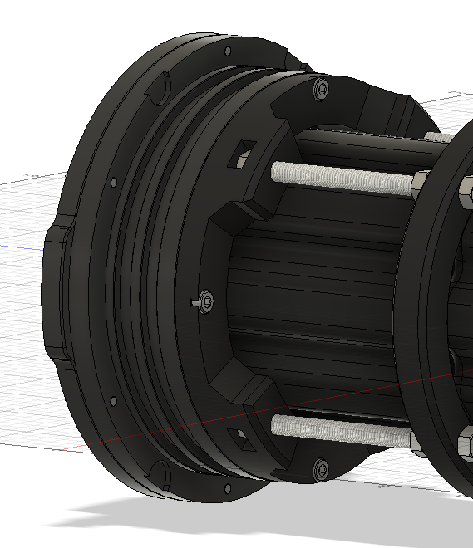

1. Separate the back flange from the platform assembly.
2. Disconnect the battery from the Raspberry Pi power connector.
3. Undo the 4 M5 nuts between the battery compartment and the platform.

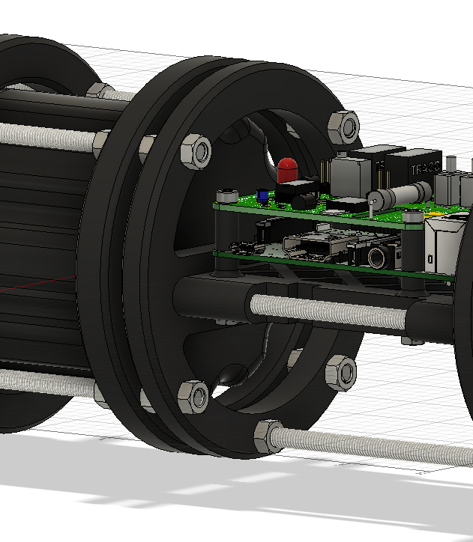

1. Pull out the battery from the compartment.
2. Using a pin, reach underneath the upper Raspberry Pi board and unclip the Pi Camera flat cable connector form both sides. Pull the cable out of the assembly.
3. Remove the Raspberry Pi by unfastening the 4 M3 mounting screws and the nuts underneath the platform.

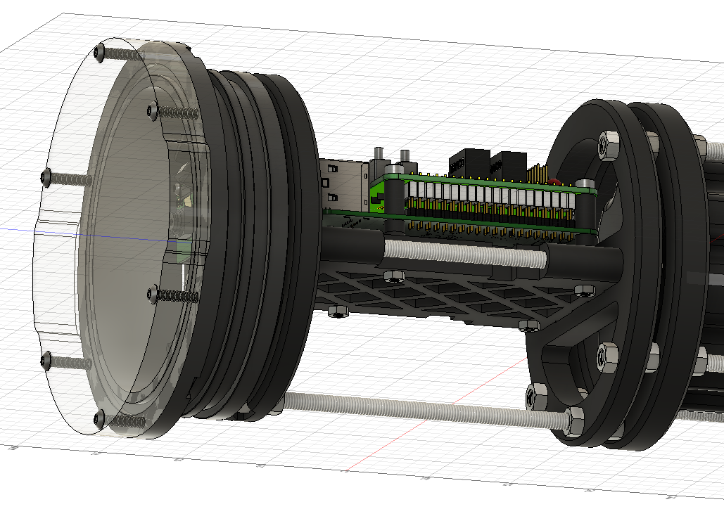

1. The rest of the frame can be disassembled starting from the nose and moving back by unfastening the M5 nuts.

## Aluminum Frame Assembly

1. Slide the battery inside the new battery compartment of the frame assembly.
2. Remove the 4 nuts M3 nuts from the flange that were installed for shipping and fasten the screws to the back flange. Tighten the screws in a rotating manner using an Allen key until the lock washers are fully compressed.

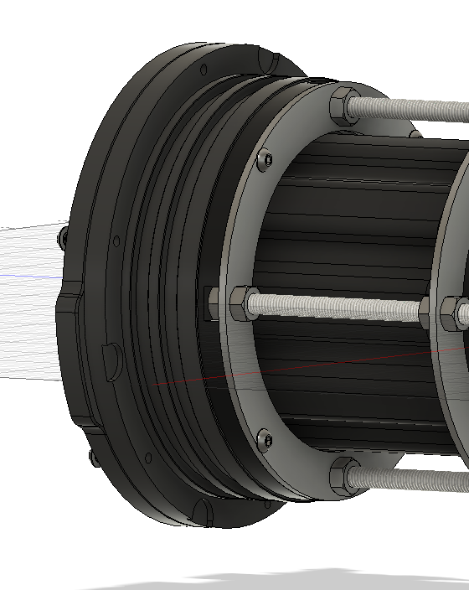

1. Mount the Raspberry Pi using 4 M3 mounting screws and plastic spacers. Shorter spaces are placed underneath the Raspberry Pi.

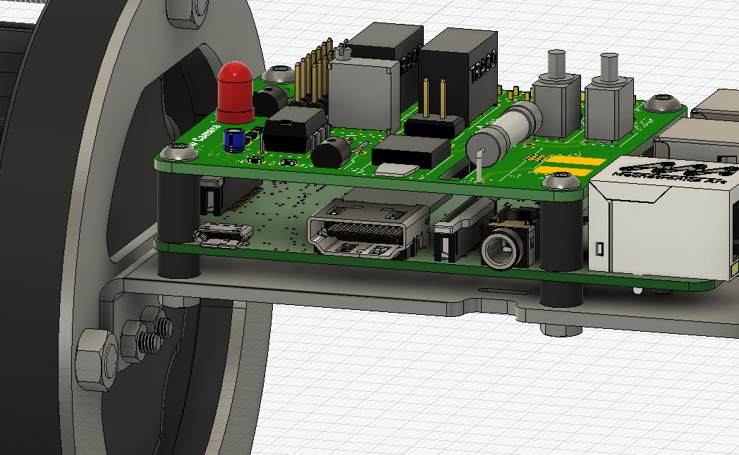

Pi platform assembly must slide back and apply pressure on the battery to fit into the housing and prevent movement. This adjustment is done by following these steps:

1. Loosen the M5 nut at the bottom at the front of the frame. Move the nut backwards by an inch.

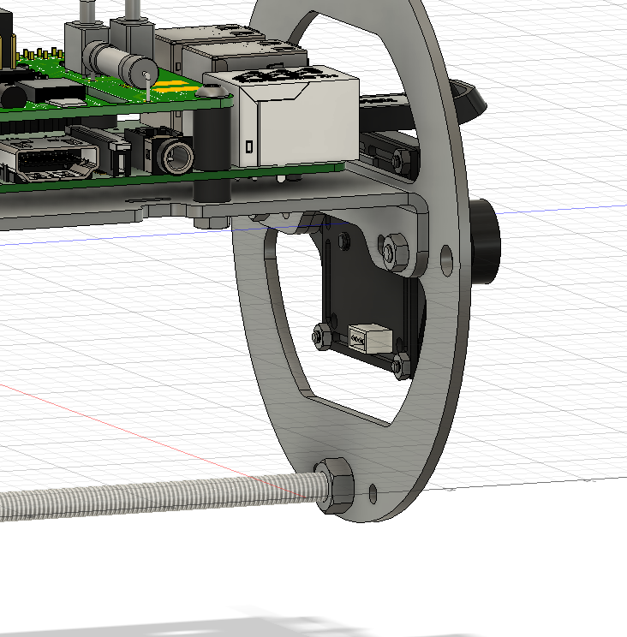

1. Loosen the M5 nut on the top of the plastic battery spacer in the middle of the frame. Move the nut backwards by an inch.

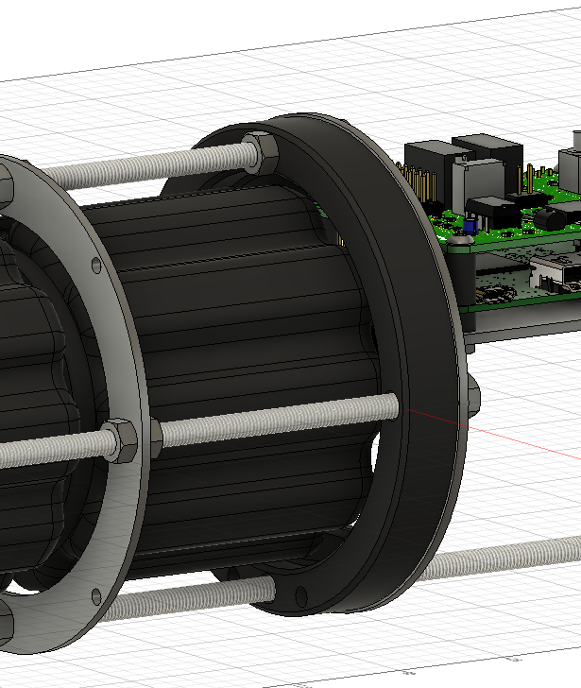

1. The Raspberry Pi platform section of the frame should move back freely after steps 4 and 5. Move the platform to the back until it presses on the battery and secures it firmly in place and tighten the 3 M5 nuts on the platform flange equally to secure the battery in place.

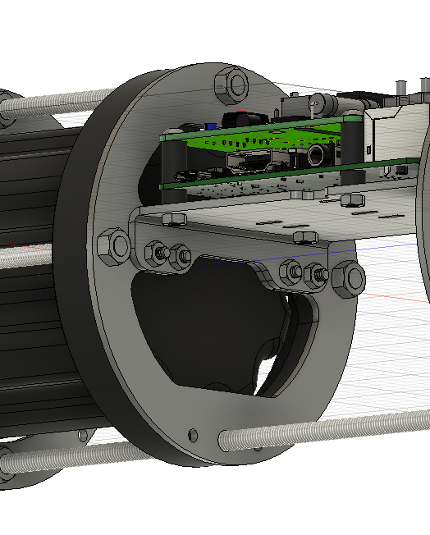

1. Move the 2 loosened nuts in step 4, 5 forward, and tighten them to prevent the structure from flexing.
2. Use the slots provided underneath, and on the side of the platform, to zip tie the battery and the Pi power connectors.
3. Check the assembly at an angle to make sure it is straight and no flexing is visible.

## Aluminum Clamp Assembly

1. Remove the 6 M3 screws from the flange using an Allen (hex) key. Note: with the screws removed the flange will separate into 2 pieces with an O-ring in between, keep the pieces together.

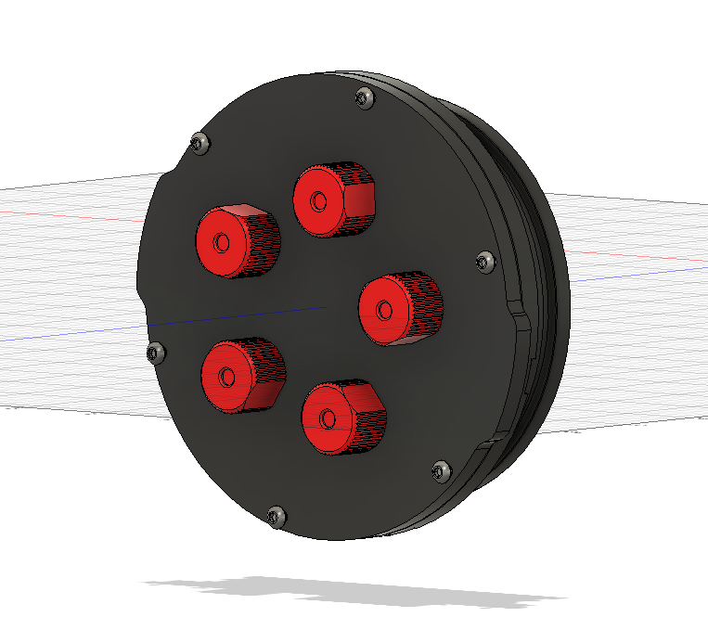

1. Align the mounting holes on the aluminum ring with the flange and fasten the screws 6 screws back through the clamp ring. Tighten the screws in a rotating fashion until the flange pieces join, and fully compress the O-ring.

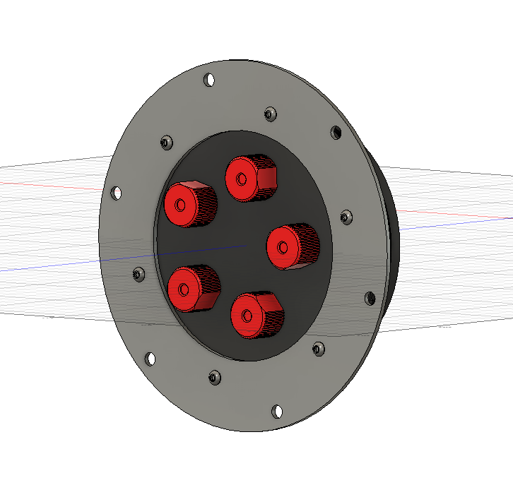

1. Repeat steps 1 and 2 for on the front acrylic flange.